我是瑞斯拜四六级

**预备课1 词汇构词法-词根词缀**

**预备课1 词汇构词法-词根词缀**

In this study guide, you will learn about common prefixes and suffixes in English. You will discover how these change the meaning and form of a word. Examples are given to show you exactly how to use these prefixes and suffixes. Check out the exercises at the end to test your understanding! You can also download this guide as a free pdf to use offline. Let’s dive in!

**What you will learn:**

* [Prefixes – meanings & use](https://onlineteachersuk.com/prefixes-and-suffixes/" \l "part1)
* [Suffixes – common suffixes for nouns & adjectives](https://onlineteachersuk.com/prefixes-and-suffixes/" \l "part2)
* [Spelling rules & word families](https://onlineteachersuk.com/prefixes-and-suffixes/" \l "part3)
* [List of common prefixes & suffixes (with examples)](https://onlineteachersuk.com/prefixes-and-suffixes/" \l "part4)
* [Prefixes & suffixes: exercises](https://onlineteachersuk.com/prefixes-and-suffixes/" \l "quiz)

Prefixes and suffixes are collectively known as ‘affixes’. Some words have both a prefix and a suffix, for example:

prefix + root word + suffix

**un-**comfort-**able**

Understanding how words are formed using prefixes and suffixes can help you work out the meaning of words and make sense of difficult spellings.

## Prefixes: meanings and use

The most commonly-used prefixes are those that change an adjective with a positive meaning into one with a negative or opposing meaning, for example: uncomfortable. Prefixes that change the word to a negative meaning include: in-, ir-, im- and dis-. Examples formed using this type of prefix are: inactive, irregular, impossible and dishonest.

|  |  |  |
| --- | --- | --- |
| **Prefix** | **Meaning** | **Example** |
| anti- | opposed/to prevent | **anti**dote |
| counter- | opposite/ opposed to | **counter**productive |
| de- | something is removed or reduced | **de-**activate |
| dis- | negative/opposite | **dis**advantage |
| ex- | former | **ex-**wife |
| extra- | outside/beyond | **extra-**curricular |
| fore- | before | **fore**warn |
| homo- | same | **homo**sexual |
| hyper- | very/extremely | **hyper**-sensitive |
| il- | negative/opposite | **il**logical |
| im- | negative/opposite | **im**mature |
| in- | negative/opposite | **in**expensive |
| inter- | between | **inter**national |
| ir- | negative/opposite | **ir**regular |
| mal- | bad/wrong | **mal**practice |
| mid- | middle | **mid**winter |
| mis- | bad/wrong | **mis**place |
| mono- | one | **mono**rail |
| neo- | new | **neo**classical |
| non- | not | **non**descript |
| omni- | all | **omni**vore |
| out- | outside/beyond/bigger | **out**weigh |
| pre- | before | **pre-**date |
| re- | again | **re-**arrange |
| semi- | half | **semi**circle |
| sub- | under | **sub**merge |
| super- | bigger/more powerful | **super**hero |
| un- | negative/opposite | **un**believable |
| under- | beneath/not enough | **under**play |

Some groups of prefixes have very specific meanings and uses. The table below summarises the most common prefixes for metric measures, those that describe multiples of units and those indicating fractions of units.

|  |  |  |
| --- | --- | --- |
| **Prefix** | **Meaning** | **Example** |
| deca- | ten times a unit | **deca**thlon |
| kilo- | one thousand times a unit | **kilo**metre |
| mega- | one million times a unit | **mega**byte |
| giga- | one billion units | **giga**watt |
| deci- | one tenth of a unit | **deci**litre |
| centi- | one hundredth of a unit | **centi**metre |
| milli- | one thousandth of a unit | **milli**metre |
| micro- | one millionth of a unit (also means extremely small) | **micro-**organism |
| Macro- | Huge large | **marcroeconomic** |

## Suffixes: common suffixes for nouns & adjectives

Suffixes enable root words to change in different ways in order to form different classes of word. For example, the root word ‘create’ can be modified to creation (noun), creative (adjective) and creatively (adverb). Different classes of words (nouns, verbs, adjectives) have their own common suffixes.

|  |  |  |  |  |
| --- | --- | --- | --- | --- |
| **Common suffixes for adjectives** | **Example** |  | **Common noun suffixes** | **Example** |
| -able / -ible | ador**able**  terr**ible** | -ance / -ence | endur**ance**  consci**ence** |
| -ant / -ent | pleas**ant**  confid**ent** | -ant | contest**ant** |
| -ate | passion**ate** | -dom | free**dom** |
| -ful | wonder**ful** | -ee | employ**ee** |
| -ian | Canad**ian** | -er / -or | paint**er**  conduct**or** |
| -ic | energet**ic** | -ery | scen**ery** |
| -ical | method**ical** | -hood | neighbour**hood** |
| -ish | self**ish** | -ion | elect**ion** |
| -ive | posit**ive** | -ism | social**ism** |
| -less | point**less** | -ist | novel**ist** |
| -like | business**-like** | -ity | regular**ity** |
| -ous | adventur**ous** | -ment | improve**ment** |
| -some | weari**some** | -ness | sad**ness** |
| -y | nois**y** | -ship | friend**ship** |
|  |  | -ure | Clos**ure** |

|  |  |  |  |  |
| --- | --- | --- | --- | --- |
| **Adverb suffixes** | **Examples** |  | **Verb suffixes** | **Examples** |
| -ly | quick**ly** | -en | eat**en** |
| -wise | clock**wise** | -ise | energ**ise** |
| -ward | north**ward** | -ate | altern**ate** |

## Spelling rules & word families

##### 3.1. Suffix spelling rules

The following rules apply to British English spelling. See also the section below on American spelling rules.

For most short words ending in a single consonant, double the consonant when adding a suffix, e.g. big/bigger. For longer words ending in ‘-l’ you should also double the consonant, e.g. travel becomes traveller. Many verbs also follow this rule, for example modelling.

For words ending in ‘-e’, the final ‘e’ is often dropped when a suffix beginning with a vowel is added. Examples include: evolve/evolving and irritate/irritable. The ‘e’ is sometimes kept to help with pronunciation, for example, in the word knowledgeable.

This same spelling pattern occurs in manageable and changeable. Some words have two alternative spellings. For example loveable and lovable are both correct spellings. Words ending in ee, oe and ye do not drop the ‘e’ when a suffix is added. Examples include seeing and canoeing.

##### 3.2. American spelling

There are some differences in spelling between British and American English. Here are some common differences:

|  |  |
| --- | --- |
| American English | British English |
| analyze | analyse |
| traveled/traveling | travelled/travelling |
| defense | defence |
| civilization | civilisation |
| center | centre |
| humor | humour |
| dialog | dialogue |

##### 3. 3. Word families

“Word families” are groups of words where different suffixes have been added to the same root word. It would be very difficult to learn all the word families in English, but knowing a few common word families can help you to learn spelling patterns and common prefix and suffix meanings.

English examinations often require students to ‘transform’ words by adding the appropriate prefixes and suffixes. So, familiarising yourself with prefixes and suffixes could help with your exam skills as well as your vocabulary.

The following word families demonstrate how root words can be transformed to create different forms with similar meanings.

|  |  |  |  |
| --- | --- | --- | --- |
| **Verb** | **Noun** | **Adjective** | **Adverb** |
| succeed | success | successful | successfully |
| specialise | specialism | special | especially |
| attract | attraction | attractive | attractively |
| surprise | surprise | surprising | surprisingly |

##### 4. Hyphen or no hyphen?

In most cases where a prefix is added to a word, no hyphen (-) is used. However, hyphens can be used in some situations to make the meaning of the word clearer and to avoid confusion.

One example is where the prefix ends with the same letter that the word starts with. For example co– and owner. Adding co- without a hyphen could change the pronunciation of the word and make the meaning difficult to understand. For this reason co-owner is clearer than coowner.

Confusion can also occur where the word has two meanings. For example, a remark is a spoken comment, but re-mark means to mark/assess an exam again. Using a hyphen in this situation can avoid confusion.

A hyphen is often used with a prefix before a proper noun. Examples include: un-American and anti-British. Finally, the prefixes ex-, self- and co- are often used with a hyphen.

## Prefixes & suffixes – examples

The list below summarises commonly used prefixes and suffixes in English. Example sentences are also provided to help you understand them in context.

##### Prefixes examples

**Anti-**

antiseptic, anti-climax, antifreeze, antibiotic, antibody, anticlockwise

The atheletes ran around the track in an anticlockwise direction.

Many infections can be treated with antibiotics.

**Counter-**

counterpart, counterproductive, counterclaim

Putting too much pressure on young people can be counterproductive.

**De-**

deteriorate, derail, deactivate

The discussion deteriorated into an argument.

**Dis-**

dissatisfied, disappointed, disloyal, disobedient, disruptive, distrust

Jane never did what she was told. She was a disobedient child.

Rob was disappointed when he didn’t get the job.

**Ex-**

ex-wife, ex-teacher, ex-husband, ex-policeman

I still meet my ex-husband sometimes.

No, he wasn’t a teacher before. He’s an ex-policeman.

**Extra-**

extracurricular, extracellular, extraordinary

Her journey across the world was extraordinary.

**Fore-**

forewarn, foreground, forefathers, forecast, forego, forefront

This robotics company is at the forefront of modern technology.

The weather forecast for tomorrow is good.

**Homo-**

homogeneous, homophone, homosexual

Air is a homogeneous mixture.

**Hyper-**

hypersensitive, hyperlink, hyper-intelligent

A hyperlink connects one page to another

**Il-**

illogical, illegal, illiterate, illuminate

Driving under the age of 17 is illegal in the UK.

**Im-**

immature, immaterial, immediately, immense, impersonal, impatient

You need to speak to the headteacher immediately.

Jamie looks sensible but he is actually quite immature.

**In-**

inevitable, incorrect, indifferent, indoors, ineffective, insincere

The examiner told me that some of my answers were incorrect.

Unfortunately, the cancer medicine was ineffective.

**Inter-**

international, intermediate, interpreter, interval, interfere, interest

My husband is working for an international company.

Maggie decided not to be a teacher; she is training to be an interpreter.

**Ir-**

irresponsible, irrational, irregular, irrelevant

Irregular verbs are difficult to learn!

**Mal-**

malpractice, malfunction, malnourished, malnutrition

I couldn’t complete the work because laser cutting machine malfunctioned.

**Mid-**

mid-July, midweek, mid-September, mid-sentence

I’m going to go out for a walk midweek.

**Mis-**

misunderstanding, mistrust, misuse, misspell, misrepresent, mispronounce

We didn’t fall out – it was just a misunderstanding.

The newspaper report misrepresented what I said!

**Mono-**

monorail, monotone, monochrome, monotonous, monosyllable, monopoly

That song has a boring tune; it’s monotonous.

A monorail has just one rail.

**Neo-**

neonatal, neoclassical, Neolithic

Yes, that museum is a neoclassical building.

**Non-**(note the prefix ‘non’ is usually used with a hyphen)

non-event, non-stop, non-smoking, non-alcoholic, non-member, non-resident

Sorry, this is a non-smoking building.

Non-residents are welcome in the restaurant.

**Omni-**

omnivore, omnipresent

An omnivore eats plants and animals.

**Out-**

outbreak, outgrow, outrun, outweigh, outbuilding, outspoken

He has outgrown all his baby clothes now.

Overall, the advantages outweigh the disadvantages.

**Pre-**

pre-war, pre-recorded, pre-pay, pre-set, pre-tax

She has a pre-recorded message on her phone.

You can pre-pay for your dental treatment.

**Re-**

replay, rerun, re-record, re-write

She had to re-write her essay to get a higher grade.

The football match last weekend was a replay.

**Semi-**

semicircle, semi-darkness, semi-detached, semi-literate, semi-professional

They left the restaurant in semi-darkness.

Mary is a great tennis player. She is semi-professional.

**Sub-**

subtropical, subsection, sub-zero, subnormal, subsoil

They had to cope with sub-zero temperatures.

Much of North Africa has a sub-tropical climate.

**Super-**

supermarket, supernatural, super-tanker, super-rich, supervisor

Supermarkets have a greater range of products than local shops.

John has been my supervisor for the past year.

**Un-**

unbelievable, unkind, unusual, unable, uncomfortable, uncanny

My new shoes are uncomfortable.

That film was unbelievable!

**Under-**

underplay, underwear, under-valued, under-rated, under-paid

He was an under-rated actor.

I’m not selling that vase. I think it has been under-valued.

##### Suffixes examples

**-able**

unbelievable, comfortable, washable, likeable, knowledgeable, fashionable (adjectives)

Do you prefer fashionable or comfortable clothes?

Professor Smith is very knowledgeable about insects.

**-ance**

performance, allowance, disturbance, appearance, brilliance (nouns)

Tom is given a weekly allowance by his parents.

The police were called to a disturbance in the street.

**-ant**

pleasant, brilliant, disinfectant, servant, assistant, (nouns and adjectives)

We had a brilliant holiday in Spain.

He decided to employ an assistant.

**-ate**

activate, affectionate, regulate, electorate, mediate, fortunate (nouns and adjectives)

You can activate your PayPal account now.

His dog is well-behaved and affectionate.

**-dom**

freedom, kingdom, boredom (nouns)

Freedom of choice means you have more opportunity to make decisions.

**-ence**

presence, existence, occurrence, permanence (nouns)

I could feel a ghostly presence when I went into the room!

Most people dispute the existence of ghosts.

**-ent**

different, resident, president (nouns and adjectives)

She has been a resident in this area for many years.

**-er**

carpenter, painter, hotter, bigger, diner, photographer (nouns and adjectives)

He is training to be a painter.

She would love to be a photographer.

**-ery**

bravery, machinery, bakery, flattery (nouns)

You can buy bread at the bakery.

The fireman was praised for his bravery.

**-ful**

beautiful, wonderful, colourful, eventful, restful, careful (adjectives)

It was an eventful day.

I hope you have a wonderful holiday!

**-hood**

neighbourhood, childhood, priesthood (nouns)

This is a very quiet neighbourhood.

**-ible**

terrible, horrible, visible, edible (adjectives)

Is that plant edible?

Our house is visible from the road.

**-ic**

photographic, alcoholic, supersonic (adjectives)

SpaceX is planning to launch a supersonic plane.

The local pub serves alcoholic and non-alcoholic drinks.

**-ical**

historical, identical, satirical (adjectives)

John and Steve are identical twins.

**-ion**

decision, promotion, completion, election, exhaustion, deception (nouns)

The results of the election will be announced tomorrow.

She made an important decision today.

**-ism**

Cubism, socialism, criticism, heroism (nouns)

Cubism was one of the most influential art movements of the twentieth century.

**-ish**

childish, selfish, reddish, snobbish, Spanish, English (adjectives)

She looks grown-up but she is a little childish.

He has reddish hair.

**-ist**

socialist, novelist, guitarist, pianist, sexist, racist

She is a brilliant guitarist.

Sexism and racism are not to be tolerated in schools.

**-ity**

creativity, popularity, regularity, sexuality, eventuality, familiarity (nouns)

Her strength is her creativity.

Jenny carefully planned her trip to allow for any eventuality.

**-ive**

creative, positive, negative, transitive, explosive, detective (nouns and adjectives)

My brother-in-law is working as a private detective.

My mother is a creative person.

**-less**

careless, ruthless, pointless, meaningless, tasteless, powerless (adjectives)

It was a careless mistake.

Sorry, but this soup is tasteless.

**-ment**

permanent, government, employment, arrangement, management (nouns and adjectives)

She is really pleased that she now has a permanent job.

Have you got any management experience?

–**ness**

shyness, loudness, sadness, loneliness (nouns)

He had to try hard to overcome his shyness.

Loneliness can be a big problem for older people.

**-ous**

adventurous, pretentious, cautious, dangerous, spacious (adjectives)

Her new flat is very spacious.

She is really adventurous. She often travels to faraway places.

**-ship**

friendship, hardship, fellowship, premiership, citizenship (nouns)

He has kept his friendship with Tony going for 20 years.

They suffered a lot of hardship when they first arrived in the country.

**-some**

troublesome, bothersome, loathsome (adjectives)

Wasps can be troublesome in late summer.

**-ure**

closure, fracture, measure, exposure, failure (nouns)

He said the marriage broke down due to a failure to communicate openly.

She was disappointed about the closure of the business.

**-y**

funny, scary, wintry, feathery, scaly, messy

My room is always messy!

It was a beautiful wintry scene on Christmas Day.

**预备课2 听力如何训练**

**听力的学习是一个漫长的过程，是学习英语的第一步，也是最重要的一步。**

**听力在“听说读写”四个技能中 属于输入性技能，我们所需要做的就是两件事**

**1.寻找适合自己的听力活动**

**2.坚持下去**

**首先 什么叫做适合自己呢？**

**听力的材料难度 要比自己的水平稍高一点。**

**每个人水平不一样，听力材料中百分之80你应该要听得懂，这样的程度就是适合。**

**其次，如何才能坚持下去？**

**听力的活动应该融入我们的生活和兴趣，或者有的同学单纯是为了过级而学习，总之一定要有动力。**

**那我们该选择什么样的听力活动呢？**

1. **电子书**

Audiobooks are a great way to engage with English culture at the same time as improving English listening skills.

Here are my favourite places to get **free** audiobooks in English:

* [Loyal Books](http://www.loyalbooks.com/" \t "https://www.leonardoenglish.com/blog/_blank) http://www.loyalbooks.com/
* [Open Culture](http://www.openculture.com/" \t "https://www.leonardoenglish.com/blog/_blank) https://www.openculture.com/
* [Scribl](https://scribl.com/" \t "https://www.leonardoenglish.com/blog/_blank) https://scribl.com/
* [Lit2Go](https://etc.usf.edu/lit2go/" \t "https://www.leonardoenglish.com/blog/_blank) https://etc.usf.edu/lit2go/
* [Librivox](https://librivox.org/" \t "https://www.leonardoenglish.com/blog/_blank) https://librivox.org/
* [Project Gutenberg](https://www.gutenberg.org/" \t "https://www.leonardoenglish.com/blog/_blank) https://www.gutenberg.org/
* [Storynory](https://www.storynory.com/" \t "https://www.leonardoenglish.com/blog/_blank) https://www.storynory.com/
* [SYNC](https://www.audiobooksync.com/" \t "https://www.leonardoenglish.com/blog/_blank) <https://www.audiofilemagazine.com/sync/>

1. 播客 podcast

我常用的是VOA

<https://learningenglish.voanews.com/>

在各大网站或者APP直接搜 podcast 有海量的内容 可以试试

B站 网易云音乐 喜马拉雅均有各种合集

1. 通过视频学习

**看视频学习听力的五个步骤**

* ****First, just watch.****Put it in full screen so the other videos on the side don’t distract you. Watch **in English with English subtitles.**
* ****Next, watch a second time.****This time, watch with subtitles in your original language if you struggled to understand the English subtitles. Focus on these so you understand what is happening in the video.
* ****Then, watch a third time.**** Watch again with English subtitles. But this time, you should have a good sense of the meaning of the video so you will likely understand more words or speech.
* ****Watch a fourth time.**** This time, take notes. Keep track of words and phrases you don’t know and their translations in your native language.

****Relax, and watch a fifth time****. This time, watch again without subtitles. Now you have a good sense of the content and new words, you should be able to understand

TED Comedy

1. 看英美剧

根据自己喜好看就好 推荐《越狱》

1. Radio 电台 这个类似于podcast  https://www.bbc.co.uk/learningenglish/english/features/6-minute-english

https://learningenglish.voanews.com/podcasts

****预备课3：如何做笔记****

# **How To Take Study Notes: 5 Effective Note Taking Methods**

If your in-class notes are messy, unorganized, and unclear at first glance, you’re not going to get much use out of them. This has nothing to do with how neat your handwriting is — it’s all about how your notes are structured.

One of the most effective ways to remember (and understand) what you are learning in class is to take effective notes in the classroom.

### **Try these 5 methods to find the best note taking method for you!**

## **The Cornell Method**

The Cornell note taking method helps organize class notes into easily digestible summaries. This method is effective because the main points, details, study cues, and summary are all written in one place.

### **Advantages:**

* Notes are neatly organized, summarized, and easy to review
* Allows you to pull out major ideas and concepts

### **What Does it look like?**

The paper is divided into 3 sections: a 2.5” margin to the left, a 2” summary section on the bottom, and a main 6” in-class note section.

1. *Use the main notes section to take notes during class.*
2. *Use the cues section to review your notes. After class, write down things you’ll need to remember and a prompt for each. You can also use this section for vocabulary words and study questions.*
3. *In the summary segment at the bottom, write a summary of your notes. This is where you will highlight the main points.*

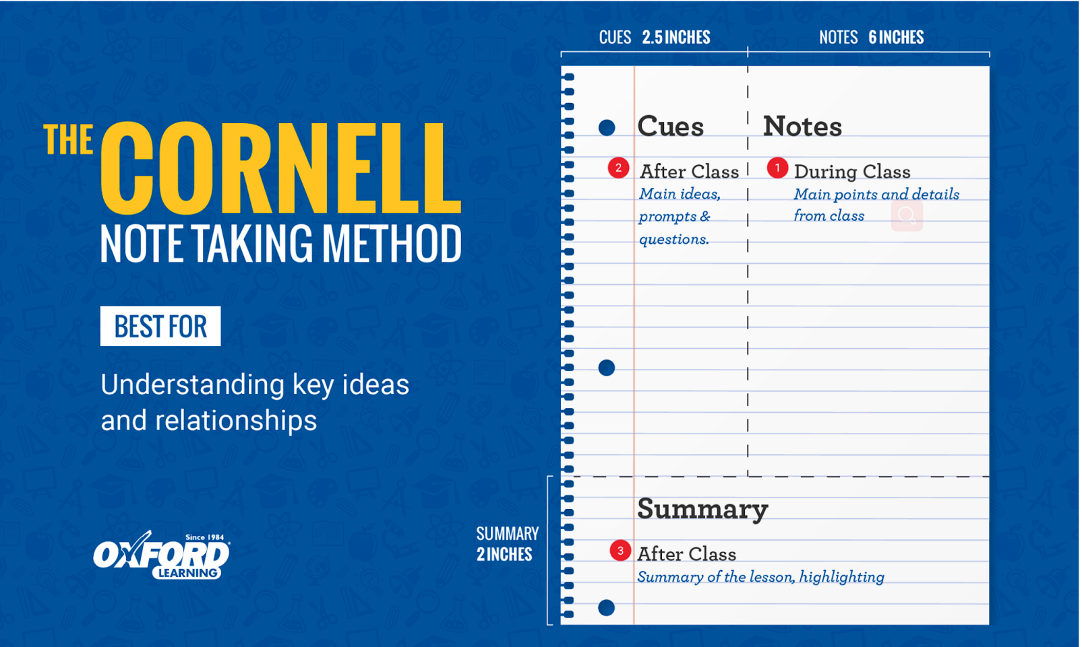

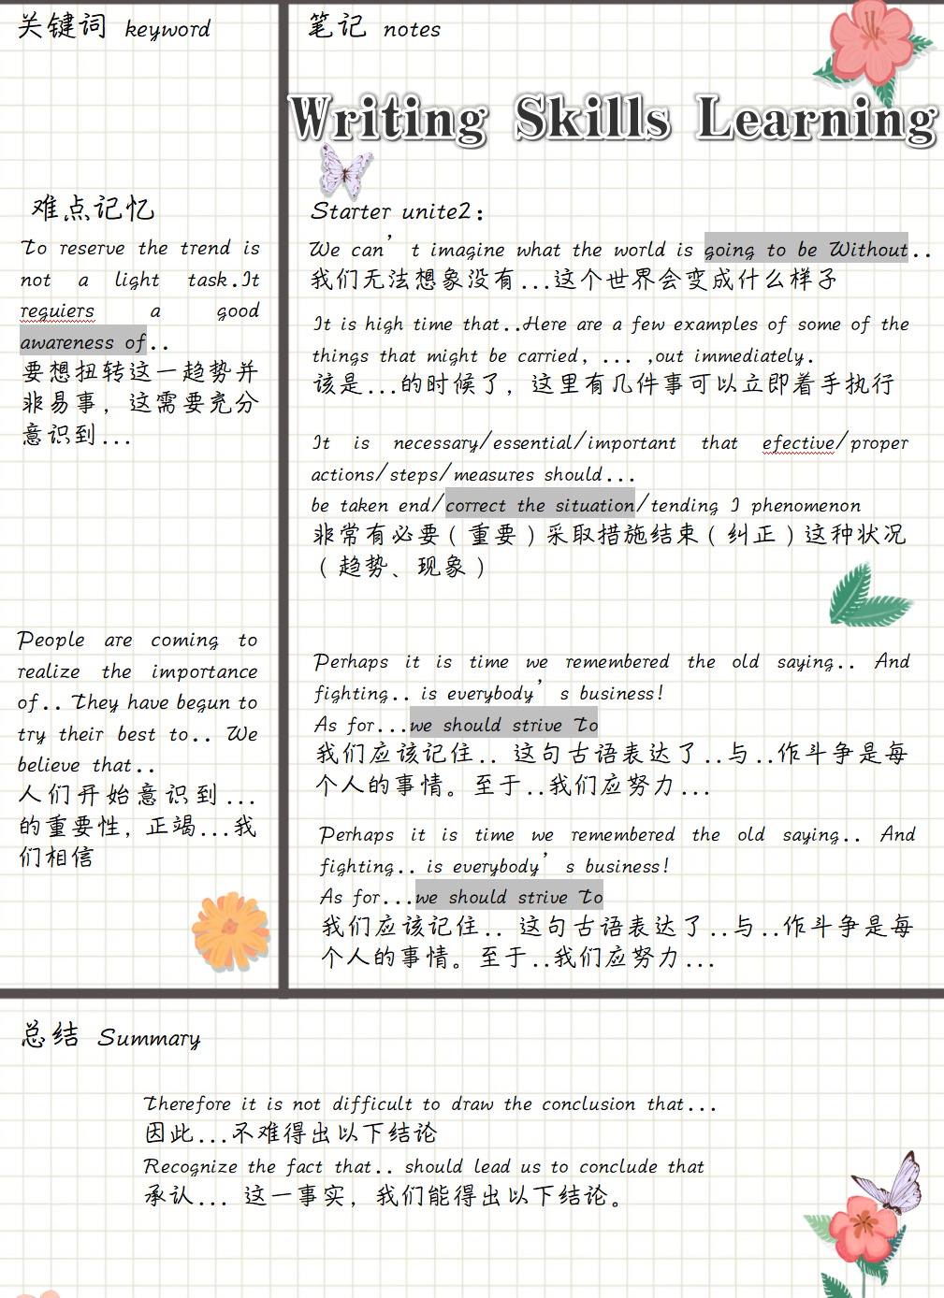**Example：**

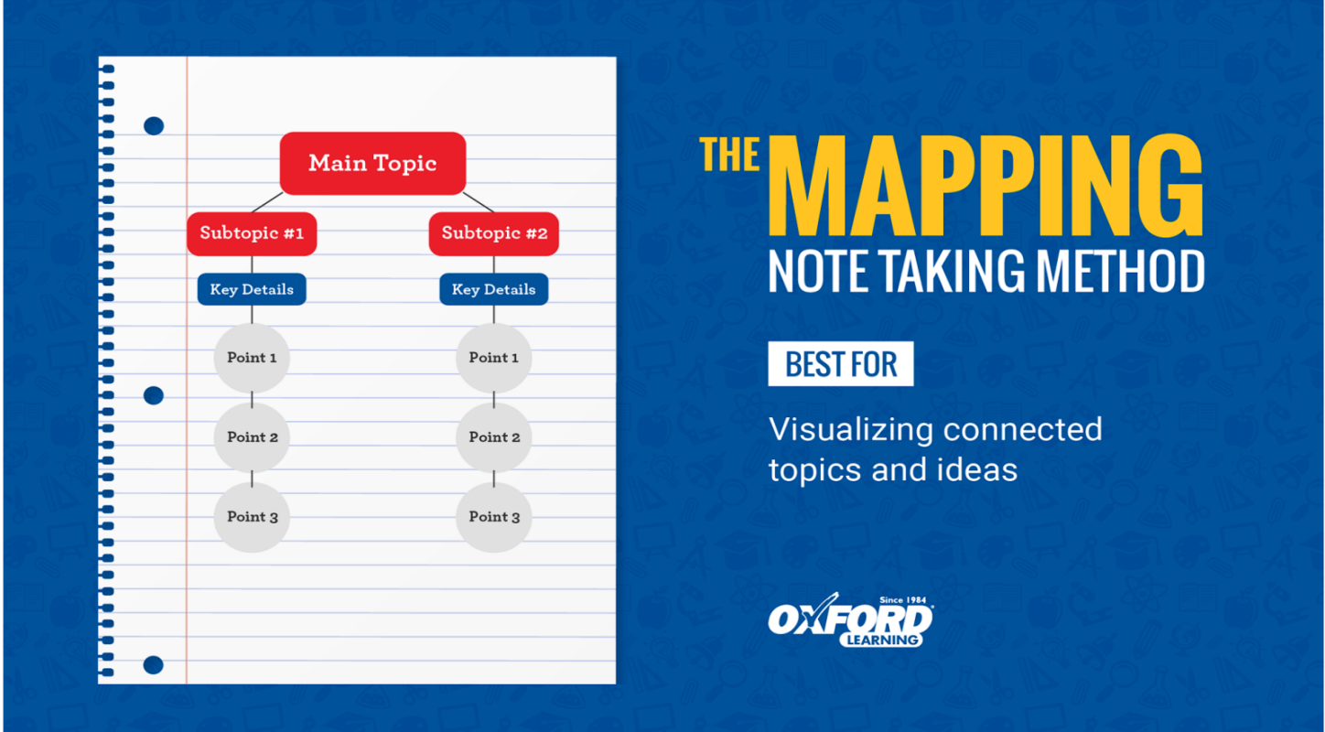

## **The Mapping Method**

The Mapping note taking method is a more visual way to organize your class notes. This technique is useful when learning about relationships between topics.

### **Advantages:**

* Useful for visual learners who struggle with studying from notes.
* Helps you remember and connect relationships between topics.

### **What Does it look like?**

The page is organized by topic. The main topics branch out into subtopics with detailed information about each.

### **How Do You Use It?**

* While in class, begin the map with the main topic.
* Branching off the main topic, write a heading for each of the subtopics.
* Write any important notes underneath each subtopic.
* Continue the pattern.

电脑软件：XMIND MIND MANAGER

## **The Outlining Method**

The Outlining note taking method uses headings and bullet points to organize topics. This method is most useful when learning about topics that include a lot of detail.

### **Advantages:**

* Allows notes to be neatly organized.
* It is easy to see the relationship between topics and subtopics.
* It is easy to turn points into study questions.

### **What Does it look like?**

Each section starts with a heading of the main topic. Each subtopic and supporting fact is written underneath the proper heading.

### **How Do You Use It?**

* During a lesson, begin your notes with a single bullet point and write the main topic.
* Place the first subtopic below and indented slightly to the right.
* 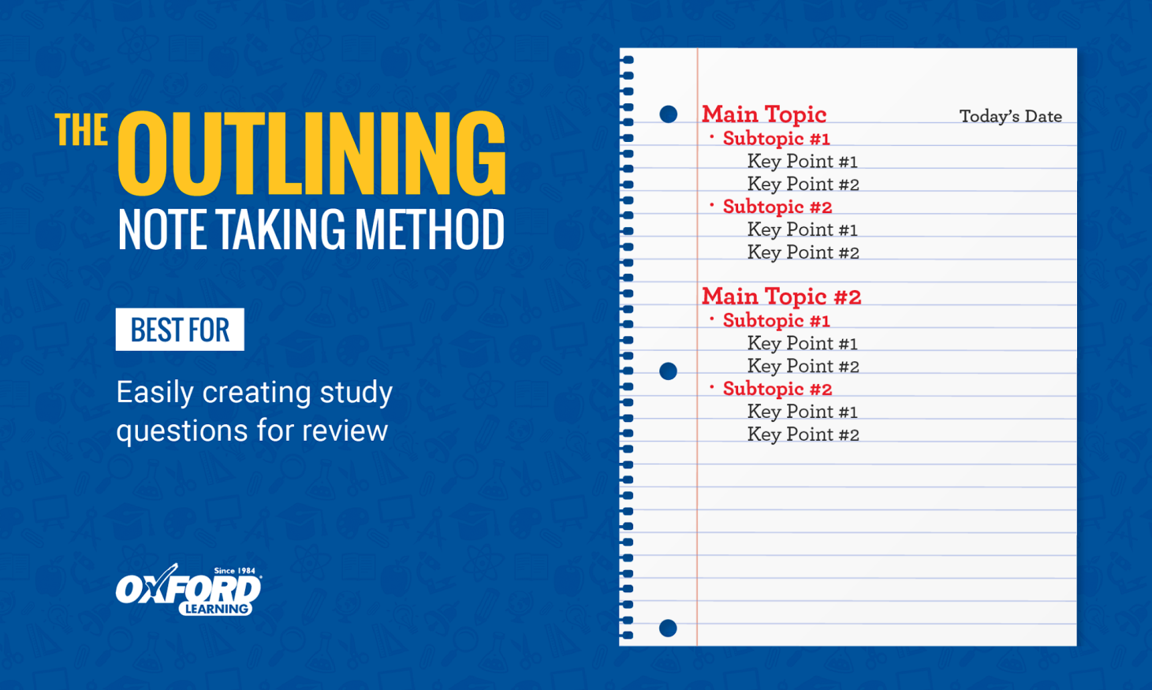List any details below your heading and slightly to the right.

## **4.The Charting Method**

Charting note taking method uses columns to organize information. This method is useful for lessons that cover a lot of facts or relationships between topics.

### **Advantages:**

* Facts are organized and easy to review.
* Highlights key pieces of information for each topic.

### **What Does it look like?**

The page is divided into columns labeled by category. The details of each category are filled out in the rows below.

### **How Do You Use It?**

* When information about a category is mentioned, jot it down underneath the proper column.
* When the next topic begins move down one row and begin again.

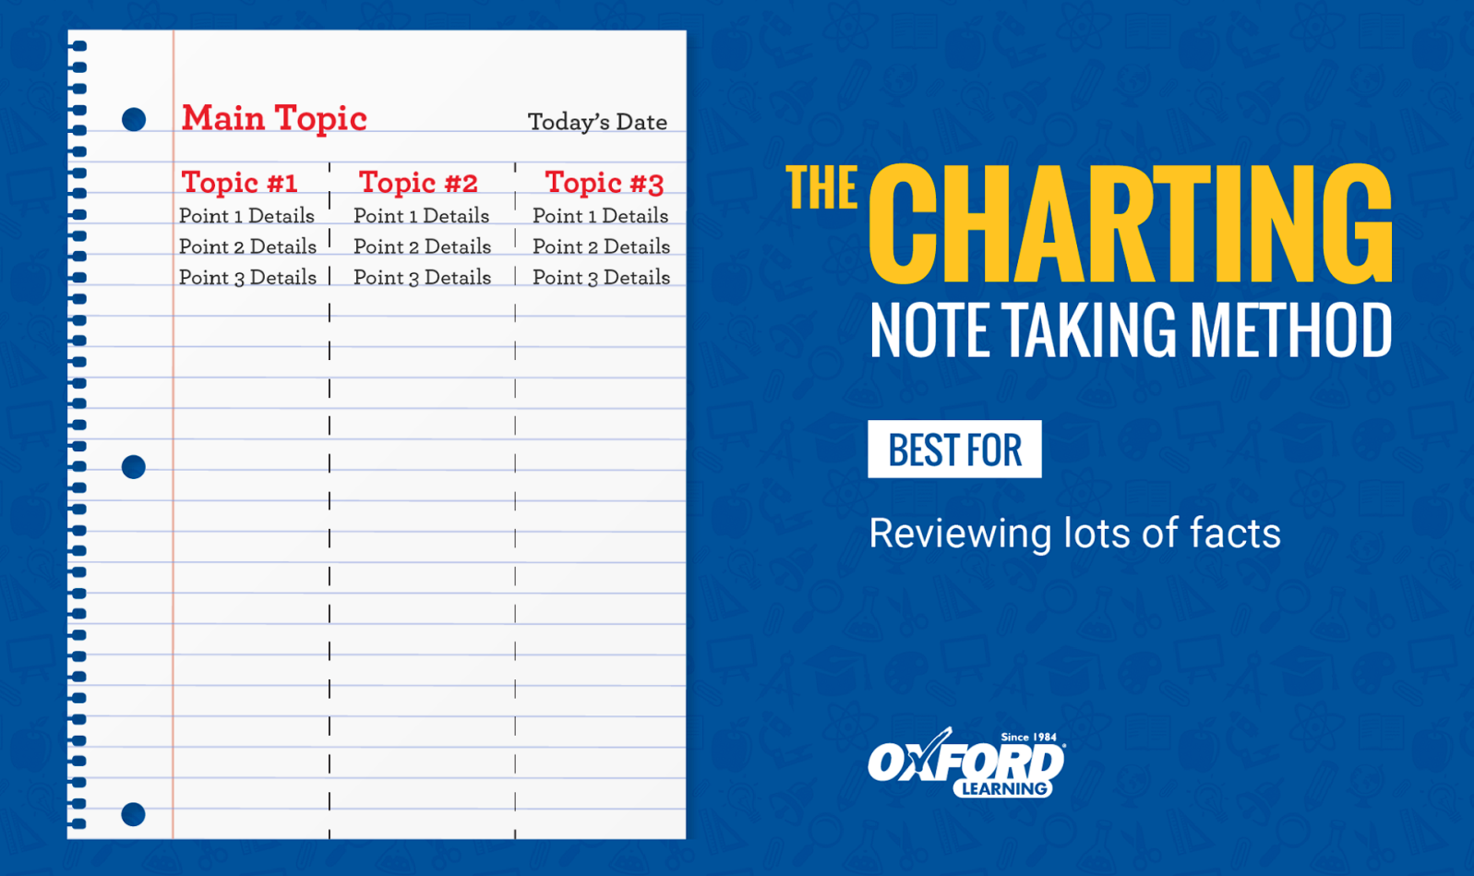

## **5.The Sentence Method**

The Sentence note taking method is simply writing down each topic as a jot note sentence. This method works well for fast paced lessons where a lot of information is being covered.

### **Advantages:**

* Jotting main points helps you determine which information is important and which is not.
* You are able to cover a lot of details and information quickly.
* Notes are simplified for study and review.

### **What Does it look like?**

Each line on the page is a new and separate topic. To organize your notes even more, you can use headings for each main topic.

### **How Do You Use It?**

* Write down important information the teacher has emphasized. This can be in sentence form or point form.
* Start a new sentence or point for each new detail.
* 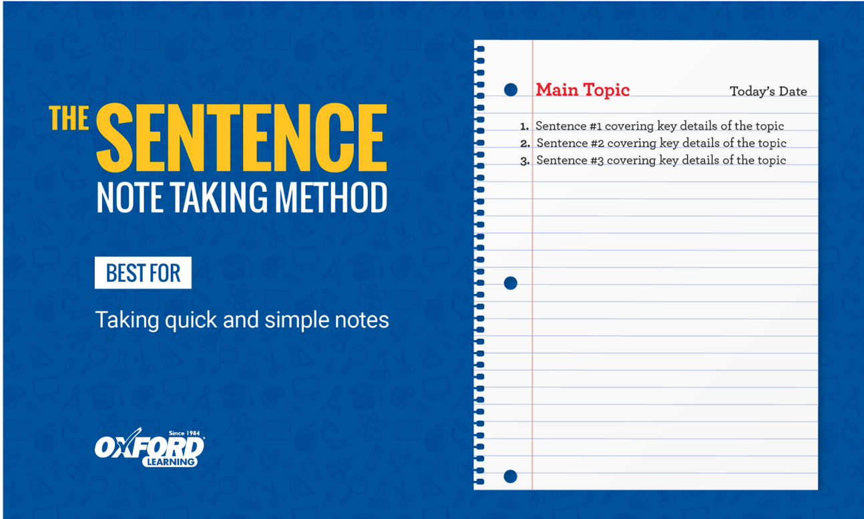Use headings to organize points by main topics.

## 预备课4：如何补充课外阅读

## Why Reading is Such an Important English Language Skill

Reading English is an important part of language learning because it helps you develop other related skills like grammar, vocabulary, and writing. Reading allows language learners to explore topics that they love and stories that engage them.

### Explore what interests you

Here are some tips for how to make the most out of your reading activities.

1. ****Make time for reading.****Setting aside a time to read directly—even marking it directly into your English study schedule—will help ensure that you actually do it. Try to read a little bit every day, even if that’s just 10 minutes.
2. ****Choose materials you like.**** Always choose materials that interest you so that you stay engaged and motivated. The more you can satisfy your curiosity with your reading material, the better.
3. ****Choose materials at the right level.**** It’s important to challenge yourself, but it’s also important to not get frustrated. You should be able to understand between 70% and 90% of what you’re reading.
4. ****Ask questions as you read.**** Thinking about what you’re reading helps keep it from simply being a [passive learning activity](https://www.leonardoenglish.com/blog/passive-language-learning-is-bullshit" \t "https://www.leonardoenglish.com/blog/_blank). You can write a summary of what you read in a reading journal for an additional [active learning activity](https://www.leonardoenglish.com/blog/active-vs-passive-language-learning" \t "https://www.leonardoenglish.com/blog/_blank).
5. ****Read it again.**** Don’t feel bad about reading something again. We often get much more out of something on the second time around.
6. ****Read a variety of texts.****You probably have your favourite genre for reading, and don’t be shy to start there. But I encourage you to explore a variety of texts. This will help give you exposure to different types of English and you might just find something new that you really like.
7. ****Don’t worry about looking words up as you’re reading.**** It’s, of course, great to find new vocabulary and put them in your [favourite vocabulary app](https://www.leonardoenglish.com/blog/how-to-build-your-own-vocabulary-app-for-free-with-just-a-google-account" \t "https://www.leonardoenglish.com/blog/_blank) . But every time you stop to look up a word, you break your rhythm. For me, it really ruins the experience. Instead, I highlight or underline new words and when I’m done reading I come back to them. That way, I can make a note of new words without losing my reading flow. One great way of doing this is on a Kindle, where you can highlight a word to see its meaning, or add it as a note to come back to later.

Want to read in English but don’t know where to start? Here are some ideas for reading materials, broken down by your reading level.

According to Stephen Krashen, professor emeritus at the University of Southern California and one of the most famous linguists of the modern era, language acquisition is driven by “[comprehensible input](https://www.leonardoenglish.com/blog/comprehensible-input" \t "https://www.leonardoenglish.com/blog/_blank)”.

Comprehensible input means content that can be understood by someone despite them not understanding every word and sentence in it.

To get this comprehensible input in English, , you have to be exposed to it.

## What can you read

Want to read in English but don’t know where to start? Here are some ideas for reading materials, broken down by your reading level.

You can also check out our favourites in our guide to [Ten Great Books for English Learners](https://www.leonardoenglish.com/blog/ten-great-books-for-english-learners" \t "https://www.leonardoenglish.com/blog/_blank).

### **Beginners: A1 and A2**

* ****The news.**** [Breaking news English](https://breakingnewsenglish.com/" \t "https://www.leonardoenglish.com/blog/_blank) is great for beginners, as is [News in Levels](https://www.newsinlevels.com/" \t "https://www.leonardoenglish.com/blog/_blank). They have news stories for beginners up to intermediate English speakers. They also have a number of quizzes to check your understanding and comprehension.
* ****Articles.**** Beginners can benefit from short, interesting articles. [Lingua](https://lingua.com/english/reading/" \t "https://www.leonardoenglish.com/blog/_blank) and the [British Council](https://learnenglish.britishcouncil.org/general-english/magazine-zone" \t "https://www.leonardoenglish.com/blog/_blank) both offer a bunch of interesting articles on a diversity of topics.
* ****Stories.**** Short stories can be great reading material at this level—especially those aimed at children. You can find a collection of easy short stories at [English for Students](http://www.english-for-students.com/English-Short-Stories-for-Beginners.html" \t "https://www.leonardoenglish.com/blog/_blank).

### **Intermediate: B1 and B2**

* ****The news.****The more difficult stories on [Breaking News English](https://breakingnewsenglish.com/" \t "https://www.leonardoenglish.com/blog/_blank) may still be good if you’re at this level. You can also try the [BBC’s News Report](https://www.bbc.co.uk/learningenglish/english/features/news-report" \t "https://www.leonardoenglish.com/blog/_blank).
* ****Articles.**** Look for articles aimed at children or intermediate English learners. Some good choices could be [Time for Kids](https://www.timeforkids.com/" \t "https://www.leonardoenglish.com/blog/_blank), [British Council magazine](https://learnenglish.britishcouncil.org/general-english/magazine" \t "https://www.leonardoenglish.com/blog/_blank), the [Smithsonian Tween Tribune](https://www.tweentribune.com/" \t "https://www.leonardoenglish.com/blog/_blank), and [Mental Floss](https://www.mentalfloss.com/" \t "https://www.leonardoenglish.com/blog/_blank).
* ****The**[Leonardo English blog](https://www.leonardoenglish.com/blog" \t "https://www.leonardoenglish.com/blog/_blank)**.****There’s lots of great stuff on this site about learning English. We look for ways to include unusual words and idioms as well.
* ****Change your phone settings.**** Many of us spend a lot of our day looking at our phones. Turn that into a reading opportunity by [changing your phone’s language settings](https://www.wikihow.com/Change-the-Language-on-a-Cell-Phone" \t "https://www.leonardoenglish.com/blog/_blank) to English. That way, you’ll read English every time you pick it up.
* ****Get English email.**** Email newsletters are becoming increasingly popular. These are usually short and use simple language. Check out [substack](https://substack.com/" \t "https://www.leonardoenglish.com/blog/_blank) and other newsletter sites to get English email sent to you regularly. You can also subscribe to the Leonardo English newsletter using the form at the bottom of this page.
* ****Books and novels.**** At this level, consider reading a book you’ve read before and really liked. I’ve been reading the [Harry Potter series to learn Portuguese](https://medium.com/@ramsay.lewis/the-secret-to-learning-a-language-how-harry-potter-is-teaching-me-portuguese-25f2658b5d16" \t "https://www.leonardoenglish.com/blog/_blank), and I’ve kept at it because I like the story and I already know it. Reading something you like will help you stick with it even when it’s hard.

### **Advanced: C1 and C2**

* ****The news.**** Follow news from English-speaking countries around the world: the [United Kingdom](https://www.bbc.co.uk/" \t "https://www.leonardoenglish.com/blog/_blank), [Canada](http://www.cbc.ca/" \t "https://www.leonardoenglish.com/blog/_blank), the [United States](https://www.cnn.com/" \t "https://www.leonardoenglish.com/blog/_blank), [Australia](https://www.abc.net.au/news/" \t "https://www.leonardoenglish.com/blog/_blank), or [New Zealand](https://www.nzherald.co.nz/" \t "https://www.leonardoenglish.com/blog/_blank).
* ****Articles.**** At this level, you can read pretty much anything. Try exploring [Medium](http://www.medium.com/" \t "https://www.leonardoenglish.com/blog/_blank) or [the Conversation](https://theconversation.com/global" \t "https://www.leonardoenglish.com/blog/_blank). [Entrepreneur](https://www.entrepreneur.com/" \t "https://www.leonardoenglish.com/blog/_blank), [Forbes](http://www.forbes.com/" \t "https://www.leonardoenglish.com/blog/_blank), and [Business Insider](http://www.businessinsider.com/" \t "https://www.leonardoenglish.com/blog/_blank) are all other popular options. The [New Yorker](http://www.newyorker.com/" \t "https://www.leonardoenglish.com/blog/_blank) and the [Atlantic](https://www.theatlantic.com/world/" \t "https://www.leonardoenglish.com/blog/_blank) feature thoughtful long-form pieces.
* ****Stories.****Check out [Reader’s Digest](https://www.amazon.com/Readers-Digest/dp/B004GVZUUY?tag=fluentu-20" \t "https://www.leonardoenglish.com/blog/_blank) for inspiring stories about people or [Modern Love](https://www.nytimes.com/column/modern-love" \t "https://www.leonardoenglish.com/blog/_blank) for incredible stories about relationships.
* ****Books and novels.**** Delight in the wide variety of English literature. You can look in the English section of your local library, or find books online. Looking for a place to start? Check out the Guardian’s list of the [100 best books written in English](https://www.theguardian.com/books/2015/aug/17/the-100-best-novels-written-in-english-the-full-list" \t "https://www.leonardoenglish.com/blog/_blank).
* Websites. Find new websites in English using services like [Mix](https://mix.com/" \t "https://www.leonardoenglish.com/blog/_blank) or [Digg](https://digg.com/" \t "https://www.leonardoenglish.com/blog/_blank).

### **Where to find books in English for free online**

Great, you’re ready to dig into a [good read](https://www.ldoceonline.com/dictionary/a-good-read" \t "https://www.leonardoenglish.com/blog/_blank)—but where can you find one? Of course, you can also [subscribe to paid ebook services](https://www.makeuseof.com/tag/go-reading-buffet-4-top-ebook-subscription-services-compared/" \t "https://www.leonardoenglish.com/blog/_blank), find an English language bookshop, or just buy an English book online… but here are a bunch of my favourite places to find ebooks online for free:

* [ManyBooks](https://manybooks.net/" \t "https://www.leonardoenglish.com/blog/_blank)
* [Librivox](https://librivox.org/" \t "https://www.leonardoenglish.com/blog/_blank)
* [Authorama](http://www.authorama.com/" \t "https://www.leonardoenglish.com/blog/_blank)
* [Project Gutenberg](http://www.gutenberg.org/wiki/Main_Page" \t "https://www.leonardoenglish.com/blog/_blank)
* [International Children’s Digital Library](http://en.childrenslibrary.org/" \t "https://www.leonardoenglish.com/blog/_blank)
* [Read Print](http://en.childrenslibrary.org/" \t "https://www.leonardoenglish.com/blog/_blank)
* [Archive.org](https://archive.org/details/texts" \t "https://www.leonardoenglish.com/blog/_blank)
* [The online books page](http://digital.library.upenn.edu/books/" \t "https://www.leonardoenglish.com/blog/_blank)
* [Open Culture](https://www.openculture.com/free_ebooks" \t "https://www.leonardoenglish.com/blog/_blank)

<https://www.newsinlevels.com/>

https://learnenglish.britishcouncil.org/skills/reading

****预备课5：大学生必须知道的英文术语****

****College vs. university:****

 Colleges are generally smaller institutions that focus on undergraduate education while universities are typically larger institutions that offer a greater number of graduate degree options.

Community College

A community college is a two-year college that serves the residents of a local or regional area. Community college students receive an associate degree after two years of successful full-time study and often technical programs of study are taught at these colleges.

Bachelor’s Degree

A bachelor's degree is a four-year program that provides in-depth, specialized knowledge in a major or field of study. Bachelor’s degrees prepare students for employment in fields ranging from accounting to theatre. The undergraduate degree can also be used to prepare for future studies at the graduate level.

Master’s Degree

A master’s degree is a graduate-level program, earned after a bachelor’s degree. A master’s degree prepares students for occupations from business to cybersecurity, or prepares students for a doctoral program.

Doctorate Degree

A doctorate degree, also referred to as a PhD, provides further training in a more specialized area.

****Commencement:****

A formal graduation ceremony that celebrates recent graduates of the institution with their family and friends.

Minor vs Major

Once you enroll in college, you will be asked to pick a major and offered the opportunity to pick a minor.

Credit hour

A credit hour is a unit used to measure the amount of schoolwork a student has enrolled for or completed.

Tuition

Tuition is the charge for attending a college or university class. Tuition prices vary depending on if you are an undergraduate or graduate student.

Transcript

A transcript is an official copy of a student’s educational record.

Semester

Usually about 16 weeks, makes up half of a college year.

Syllabus

The thing your instructors will know you didn’t read when you start asking questions about the homework. Also, a professor’s outline for class structure, assignments, required textbooks, and institution-wide and classroom specific rules and regulations.

Plagiarism

Copying someone else in part or total and claiming their work as your own. Will result in academic repercussions such as failing the assignment, failing the course, or dismissal from the college/university. (Don’t do it!)

Dissertation

Generally in reference to a doctoral dissertation. An original contribution to a student’s field of study as a result of academic research.

Thesis

Similar to a dissertation (some use the term interchangeably). A research paper covering a student’s chosen topic of study.

GPA

Grade Point Average.  Generally on a 4-point scale.

Internship

A short-term job to help gain experience and connections in a desired field of work can sometimes lead to job offers.  Different from Work-Study.  Can be paid or unpaid.

Department

Refers to a certain section of a university. Departments are usually aligned with degrees or areas of study within a college, such as the engineering department, English department, etc.

Dormitory

A dorm or residence hall is an on-campus student living facility. At some schools, only first-year students are required to live on campus, but at many smaller colleges students live in dorms all four years. Most dorm living is connected with a meal plan, and is covered by a room and board payment.

Faculty

The staff of professors and instructors at a university.

Gap Year

A year-long break between high school and college, or a semester or year taken off at some point along the way to earning a college degree.

Homesickness

A term for the emotional distress students may feel as they adjust to a new life on campus away from their home and family. [Homesickness](https://www.collegiateparent.com/student-life/helping-with-homesickness/" \t "https://www.collegiateparent.com/student-life/college-terms-you-need-to-know/_blank) is most common at the start of the first year and most students work their way through it.

MBA

Stands for Master of Business Administration. An MBA is a type of master’s degree, and typically requires a bachelor’s degree to pursue.

SAT

The Scholastic Aptitude Test, known as [the SAT](https://satsuite.collegeboard.org/sat" \t "https://www.collegiateparent.com/student-life/college-terms-you-need-to-know/_blank), is used by many colleges to determine a prospective student’s ability to succeed academically at the school. Like the ACT, the SAT is usually taken in the spring semester of the junior year of high school, and can be retaken in the fall of the senior year.

Scholarship

A financial award to help your student pay for college. Scholarships can come from the institution (the college or university) or from outside groups and organizations. Unlike student loans, this is gift money that does not need to be paid back.

STEM

STEM stands for Science, Technology, Engineering and Mathematics and is used to refer to classes or programs in these areas.

Teaching Assistant (TA)

Many large classes employ teaching assistants to help the professor. A TA may lead a small discussion section, help with labs in science courses, run study sessions and hold their own office hours.

Orientation

Incoming first-year college students are usually required to take part in orientation, either on campus or virtually. Orientation programs may be offered over the summer or may take place during welcome week and move-in. During orientation, students learn about campus resources, the student code of conduct, and may meet with their academic advisor to select fall classes.

Pass/Fail Course

A class in which no grade is given; a student simply passes or fails. A pass has no impact on GPA but a failing grade is calculated as a 0.0. Colleges limit how many (if any) classes a student can take pass/fail, and typically students may not opt for pass/fail in required general education or major classes.

Midterms

Exams that occur in the middle of a quarter or semester to test a student’s grasp of topics covered in a course up to that point. Midterms are typically weighted more heavily than other tests and coursework, but not as heavily as finals.

Finals

Exams at the end of a semester or quarter that test a student’s knowledge on everything covered in a course. In some courses, the grade on the final exam will be the biggest factor determining the student final grade in the course. Sometimes instead of an exam, the final will be a paper or big project.